  Tennis Dataset analysis  2016-2019 | Abstract  Developing models to predict tennis match outcomes from the ATP (Association of Tennis Professionals) Tour 2016-2019 and evaluating which perform best.  Edward Pearce  MAST6100

Contents

  - Page
Chapter 1 Introduction 2
Chapter 2 Exploratory Data Analysis 3
Chapter 3 Logistic Regression and Lasso 6
Chapter 4 Ridge Regularised LR 7
Chapter 5 Random Forest 8
Chapter 6 Neural Networks 9
Chapter 7 Conclusions 10

GitHub link:

Introduction

Dataset Description and Task
I have a great love for playing tennis and am interested in analysing match statistics. Therefore, this project will include some research into which statistics most heavily predict the winner of a match.
Data for this task has been pulled from Kaggle and includes all ATP matches 2016-2019. My decision in selecting these four years stems from previous analysis I have completed: some basic classification (SVM model) determined that break points faced and won/lost were the key contributors to a win or loss in matches from 2021-2024. Now I hope to do more detailed analysis of the four years leading up to the pandemic and see whether the trends are similar.
The data from Kaggle is separated by year, so I have combined the four datasets into one. This establishes that there are 11,555 rows (matches) and 49 columns (match info and stats). I have verified that the number of duplicate rows is zero, i.e. no match entry is repeated. However, there were 555 rows with at least one NA value (outside of the winner_seed and loser_seed columns), so I decided to remove these rows. The final dataset now includes 11,000 rows.
It is also important to make the dataset easily legible. Therefore, I am replacing all NA values in the winner_seed and loser_seed columns with “unseeded”. Furthermore, the date is not particularly legible, as well as not being in chronological order. I have therefore created a new date column and ordered the matches oldest to newest. Lastly, I have improved the clarity in the tourney_level column by renaming the letters to what they represent, e.g. G = Grand Slam.
The VS Code environment with version 4.4.3 of R and the latest version of each package has been used for this analysis.

EDA
The purpose of EDA is to get a better understanding of the structure of the data. This is usually achieved by producing a catalogue of plots as these are great for conveying a lot of information in a small space. We will also look at relationships between variables and identify which classification techniques our data is appropriate for. We will firstly look at outliers in our data.

Outliers
It is firstly important to visualise the number and nature of the outliers in our data. I have run code to show box plots for all numerical features.
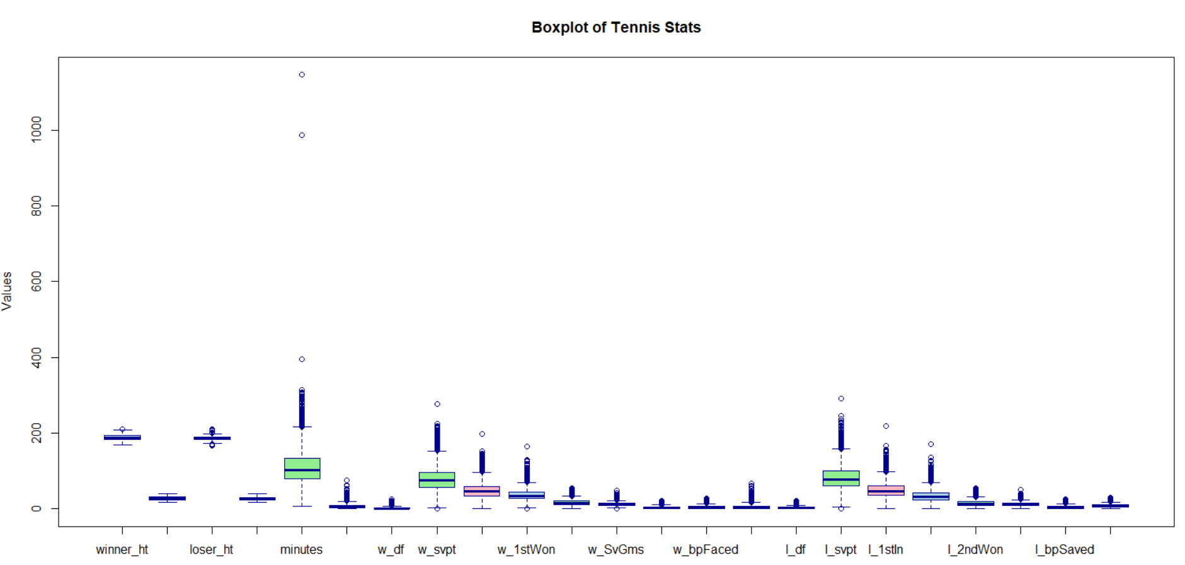
Figure 2.1: Box Plots of all numerical features
Figure 2.1 shows that our dataset has many outliers. Usually, this would be a concern as it implies the data collected is either incorrect or spurious. However, in the context of tennis, this is less problematic as matches have no defined end point, so the longer the match, the more first serves there will be etc.
On the other hand, it is worth noting that the minutes variable contains two values (approximately 1000 and 1100) that are far above the rest. I have conducted some research into these specific matches and concluded that this data is incorrect and therefore removed these two rows from the dataset. There is one further entry that has several big outliers, but this was a famous Wimbledon match between Kevin Anderson and John Isner that lasted 6 hours 36 minutes.
Overall, the box plots appear sensibly shaped. There is a clear bias of outliers in the upper end of variables because a tennis match does not have a pre-defined time limit, so matches can last extremely long. However, they cannot be extremely short (or negative) as a minimum number of sets must be played.

Correlation
Correlation measures the extent of a relationship between variables, i.e. if one increases, does another tend to increase or decrease, and to what extent. Here, I have focused on the match statistics of the winning players and produced a correlation heatmap. I have used Spearman’s Rank Correlation over Pearson’s Correlation Coefficient because it is more robust to outliers, of which we have many, and all our variables are non-normal.
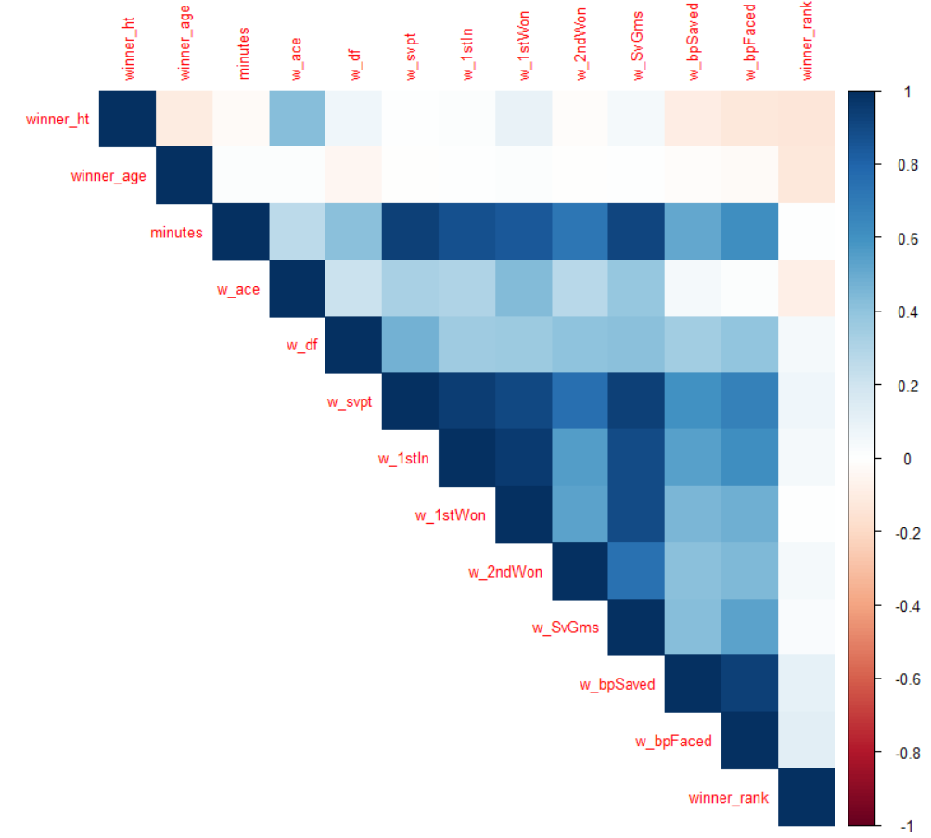

Figure 2.2: Correlation Heatmap covering Match Statistics
Figure 2.2 shows that the majority of variables have a weak-to-mid positive correlation with others. For example, the number of service games won and aces hit for the winning player have a spearman correlation coefficient of about 0.3. However, some have a very strong positive correlation. An example would be the number of service games played and match length (minutes), which have a coefficient of about 0.9. Some of the red areas, showing slight negative relationships, are also expected. For example, the winning player’s number of aces and world ranking is negative because a higher number means a lower ranking in tennis.

Histograms
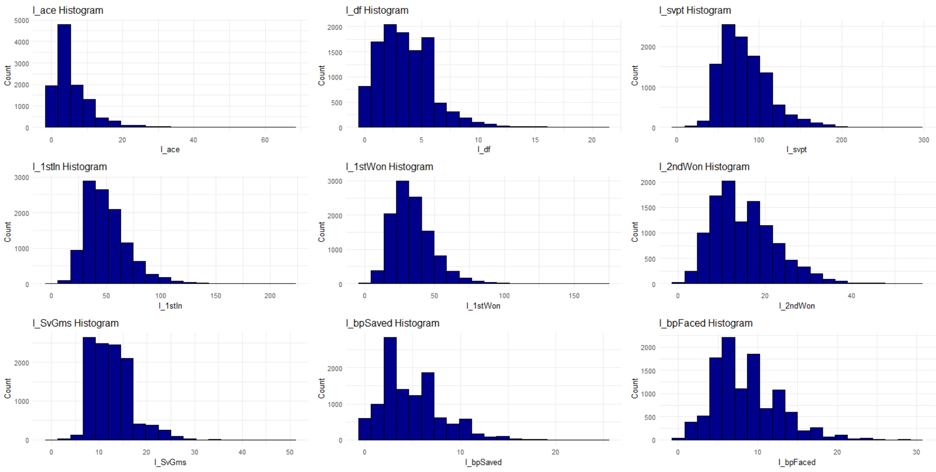
Histograms are a great visualisation of variability in a dataset, such as inspecting most common values or skewness. I have chosen nine numerical variables (match statistics of losers) depicted in the plots below.
Figure 2.3: Histograms of Losing Player Variables
Figure 2.3 shows the distributions of loser features, such as number of double faults hit and service games played. For purposes of simpler analysis, I assigned a set number of bins (or classes) to all plots and found a comprise between increasing detail and not having gaps within a plot; this number was 20.
All histograms are positively skewed, meaning the mean is larger than the median, which is expected in tennis statistics as they count up from zero. This can result in a few very large values but no negative values. The number of aces histogram is extremely unimodal, meaning there is one class more common than the rest. This implies that the loser usually manages to hit a couple despite how close the match is. The histogram showing break points saved is distinctly bimodal; this could be because matches are either best of 3 or 5 sets, which differentiates this statistic.
Before we move onto the four classification models, it is worth noting that I have restructured the dataset to make it more appropriate for our analysis: each row is now listed twice, one for the match winner and one for the loser. Fortunately, this results in exactly half of my data with outcome ‘1’ and half with ‘0’, which avoid any analysis issues derived from an imbalanced dataset. I have selected 29 variables, the majority numerical, and transformed all categorical variables into dummy variables (many machine and deep learning models prefer this input).

Logistic Regression
Logistic regression is a classification technique that can predict binary outcomes from a number of predictors. This type of general linear model is useful in machine learning due to its trade-off of interpretability and relative high performance. It achieves this with a sigmoid function that ensures predicted probabilities of outcomes lie in the range 0 to 1. An equation equating the log-odds of the outcome and predictors demonstrate linearity (an assumption of the model) and the coefficients of these predictors use maximum likelihood estimation. A basic logistic model does not usually perform well when many predictors are correlated. Given that our plot in the EDA indicated a couple of variables have stronger correlations, it will be interesting to see the results.
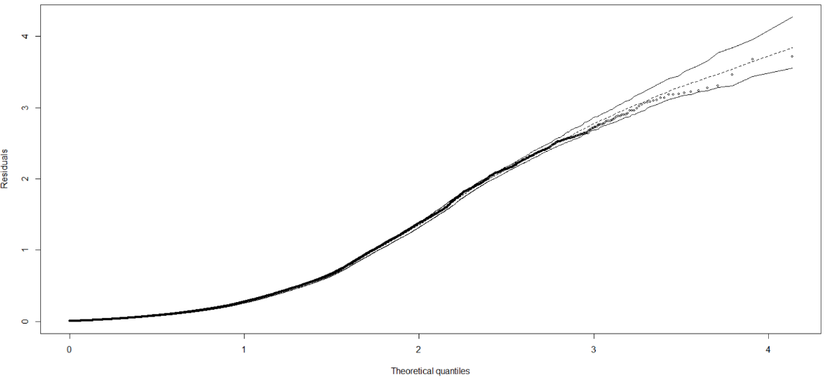
In my analysis, I have firstly shuffled the rows of my dataset so that the training process is representative of unseen data. Then I split my data 80/20 train/test which is a standard splitting ratio. I used 5-fold cross validation on the training data, meaning the model is trained four times, leaving a validation set spare on each iteration. Then I fitted the basic logistic regression model with all predictors. The model summary indicated that there were a number of significant predictors, even at the 0.1% level. These include win percentage on first serve, number of double faults, number of points won off second serve, serve games played, break points faced, and break points saved. Here is a half-normal plot of residuals. As all points fall within the black lines, this model is a suitable fit to the data. This model achieved an accuracy of 93.6% on the test set.
Figure 3.1: Basic Logistic Regression Half-Normal Plot

